Breast DCIS.
Stem: 55y postmenopausal female with no past medical or surgical history is referred to the office for calcifications seen in the upper outer quadrant of the left breast on annual screening mammogram that weren’t appreciated on the mammogram the year prior. She denies any changes in her breasts or axillae.
Family history is negative for breast or gynecologic malignancies.
Her physical exam is unremarkable.

What is your Differential Dx?
- DCIS
- LCIS
- Invasive breast cancer
- Atypical ductal or lobular hyperplasia
- Fibrocystic changes
- Fat necrosis

Additional Workup or Studies?

- Diagnostic mammogram : Fine linear branching calcifications located near the chest wall in the upper, outer quadrant of the left breast; the calcifications appear focal and do not appear to be multicentric
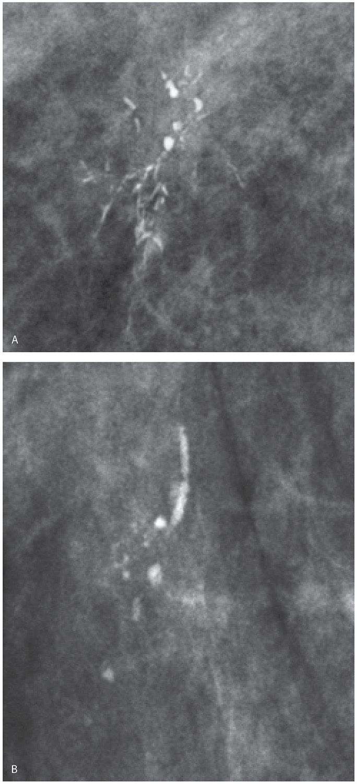

- Stereotactic core needle biopsy: Returns as DCIS

What would you like to do now?
- Surgery:
    - Localization
    - Breast conserving surgery with postoperative radiation (no SLNB)
    - (or) Simple mastectomy with sentinel lymph node biopsy +/- reconstruction

Pathology returns as ER/PR + high grade DCIS, what treatment you would recommend?
5 years of anastrozole

Describe Breast Conserving Surgery
- Preprocedural localization of nonpalpable lesions.
- Plan incision on lesion depth and location, with consideration of future mastectomy incision.
- Excise the localized lesion with grossly normal 1-cm margins.
- Orient specimen and send to mammography to ensure the wire, clip, and lesion or calcifications are in the specimen.
- Palpate the cavity for any suspicious tissue.
- Ensure hemostasis and close.

CQ3 BREAST LCIS
Stem: You are seeing a 58y postmenopausal female after a routine mammogram showed calcifications the right breast, they weren’t appreciated on the mammogram the year prior. She denies any changes in her breasts or axillae. Family history is negative for breast or gynecologic malignancies. Her physical exam is unremarkable.

What is your Differential Dx?
- DCIS
- LCIS
- Invasive breast cancer
- Atypical ductal or lobular hyperplasia
- Fibrocystic changes
- Fat necrosis

Additional Workup or Studies?

- Diagnostic mammogram reveals fine linear branching calcifications located near the chest wall in the upper, outer quadrant of the right breast; the calcifications appear focal and do not appear to be multicentric
- Stereotactic core needle biopsy

core needle biopsy returns as LCIS (ER/PR +, HER2/neu negative). You proceed to OR for excisional biopsy, Pathology returns LCIS, positive inferior margin

What would you like to do now?

- Observation:
- H&P q6 months x5y
- Mammogram in 6 months then annually
- Anastrozole or raloxifene

- bilateral prophylactic mastectomy +/- reconstruction, however usually reserved/recommended for patients with strong family history and/or high genetic risk.

(To examiner: Examinee should recognize that LCIS is a marker of increased risk but not an actual precursor lesion therefore -no tumor on ink- does not apply)

Describe a mastectomy
- Orient elliptical incision to include nipple–areolar complex, previous biopsy site, and overlying skin.
- Use electrocautery and gentle traction to develop the connective tissue plane superficial to the breast parenchyma in creation of the skin flaps.
- Dissection borders are superiorly to the clavicle, medially to the lateral border of the sternum, inferiorly to the anterior rectus sheath, and laterally to the anterior border of the latissimus dorsi muscle.
- Remove the breast from the pectoralis muscle, including the pectoralis fascia.
- Perform sentinel lymph node biopsy utilizing the same incision.
- Ensure hemostasis, place drain, and close.

DQ2 Breast Ductal Papilloma
What is most likely diagnosis?
Stem: 59y postmenopausal female presenting with complaints of unilateral bloody nipple discharge from the right breast. Mammogram is unremarkable.

Intraductal papilloma

What would you like to do now?

- Ultrasound vs MRI vs contrast ductography: US demonstrated a dilated duct in the right periareolar area

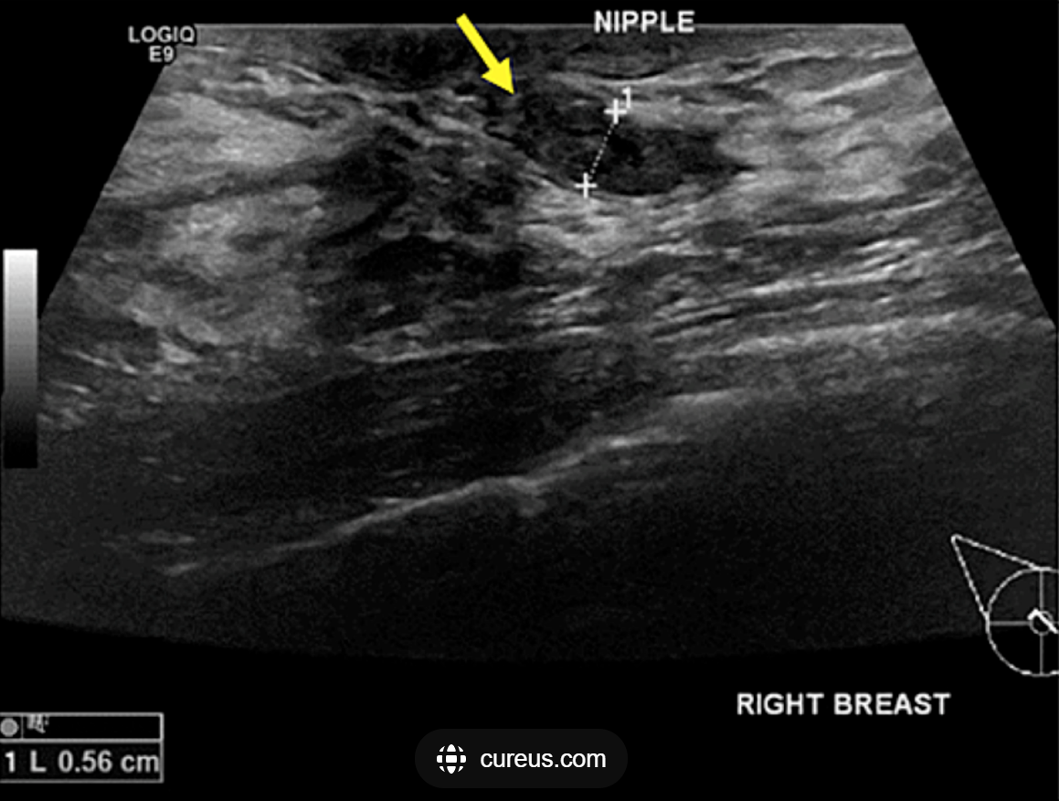

- Ultrasound guided biopsy: indeterminate

- OR:

Describe:

- Terminal duct excision/excisional biopsy
- Insert a fine lacrimal duct probe into the dilated duct.
- Make a periareolar incision (no more than 30% circumference
- Isolate the affected duct
- Resect the subareolar region with the abnormal duct attempting to preserve unaffected duct(s) if possible.

- Pathology : Confirming.

